Market Monitor - South Sudan - 2026-01

Highlights
Market prices continued to escalate in January, driven by substantial year-on-year inflation in staple foods and livestock, further eroding household purchasing power.
The cost of a standard food basket rose to SSP 954,026, marking an increase of 7.2% since December and 41.7% over the past year. Price increases were most pronounced for tomatoes (↑15.5% MoM), maize meal (↑11.1% MoM), and local sorghum (↑9.6% MoM).
Key drivers of the market trends include:
- High year-on-year inflation for staple cereals, with local sorghum increasing by 72.4% and maize meal by 50.6%.
- Significant price hikes for livestock, with the cost of sheep and goats rising by 51.9% and 46.1% year-on-year, respectively.
- Elevated transportation costs, driven by high parallel market fuel prices, which continue to exert upward pressure on commodity prices.
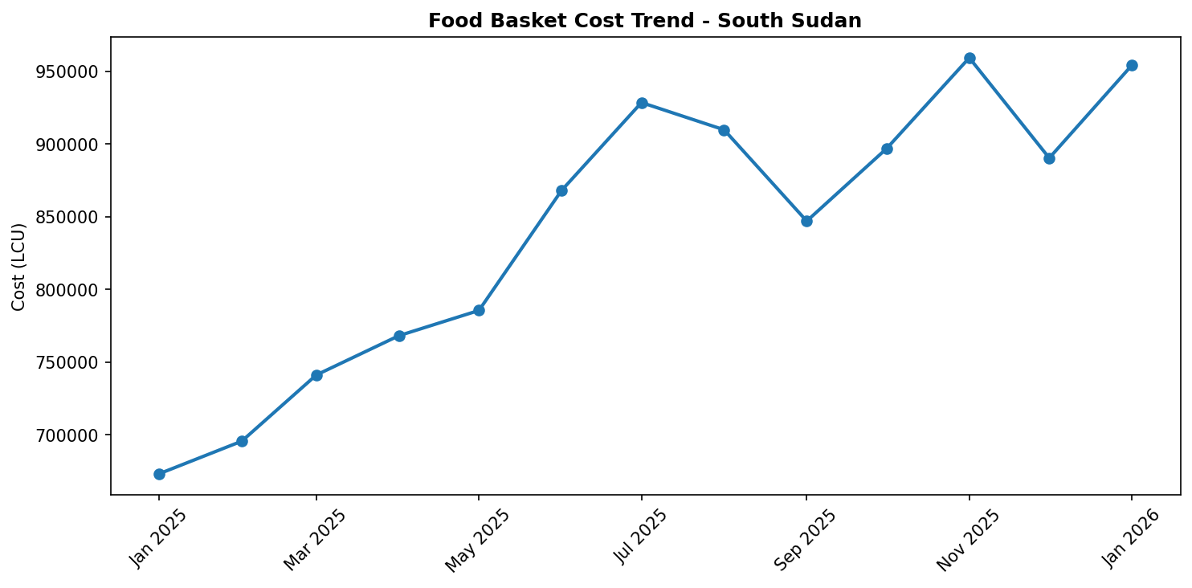
Food basket cost trend

Market Overview
Market conditions across South Sudan continued to deteriorate in January 2026, characterized by a persistent and accelerating increase in the price of essential goods. The primary drivers of this inflationary trend include severe year-on-year (YoY) inflation for staple foods, significant currency depreciation which elevates the cost of imports, and extremely high parallel market fuel prices that inflate transportation costs. These economic pressures are key drivers of a worsening food security situation, which is projected to expand to Emergency (IPC Phase 4) levels in 35 counties by May 2026. The economic decline is compounded by the protracted impacts of nationwide flooding and escalating conflict, which further disrupt supply chains and constrain market functionality. The strong monthly price increases observed for staple cereals suggest that the upward price trajectory will continue in the near term, placing immense strain on household budgets and severely eroding the purchasing power of the most vulnerable populations across the country.

Commodity Analysis
An analysis of key commodities reveals that staple cereals are the main contributor to the rising cost of the food basket. Local sorghum prices experienced a dramatic surge, rising 9.6% month-on-month and a staggering 72.4% year-on-year, indicating critical supply constraints. Maize and maize meal followed a similar trend, with YoY prices increasing by 48.1% and 50.6%, respectively; the 8.7% monthly rise in maize milling costs is directly impacting the retail price of maize meal.
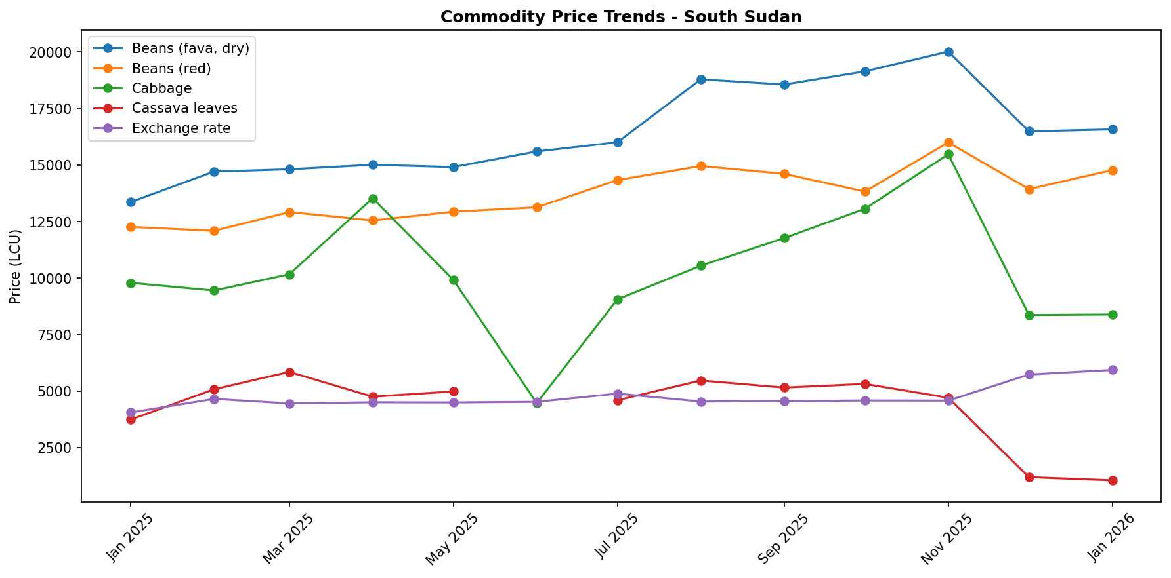
Livestock prices also reflect the broad inflationary pressures, with sheep and goats increasing by 51.9% and 46.1% YoY. These high prices are fueled by high parallel market fuel costs, with petrol and diesel up 82.0% and 70.4% YoY, respectively. These fuel costs add a significant burden to all supply chains. In contrast, the market for fresh produce showed mixed trends. While tomatoes saw a sharp monthly spike of 15.5%, prices for locally produced items like cassava leaves and cabbage collapsed over the year, falling by 71.9% and 14.3%. This divergence suggests that while the markets for cereals and imported goods are under severe stress, local vegetable supply may be more robust in certain areas, offering limited relief.

Regional Highlights
The severe economic pressure on households is acutely evident in Renk, where qualitative reports of rising market prices and limited daily labour opportunities are substantiated by quantitative data. The cost of the food basket in Renk increased by 41.7% over the past year. During the same period, the real wage for non-qualified labour—what that wage can actually buy—decreased by 19.5%. This demonstrates a severe erosion of purchasing power, where the cost of living is rising more than twice as fast as wages are falling behind. The direct impact of this economic squeeze is clear, as communities in and around Renk reported having insufficient food in late 2025. The convergence of high prices and diminished income opportunities in Renk provides a stark example of the deteriorating economic conditions faced by vulnerable households across many parts of South Sudan.
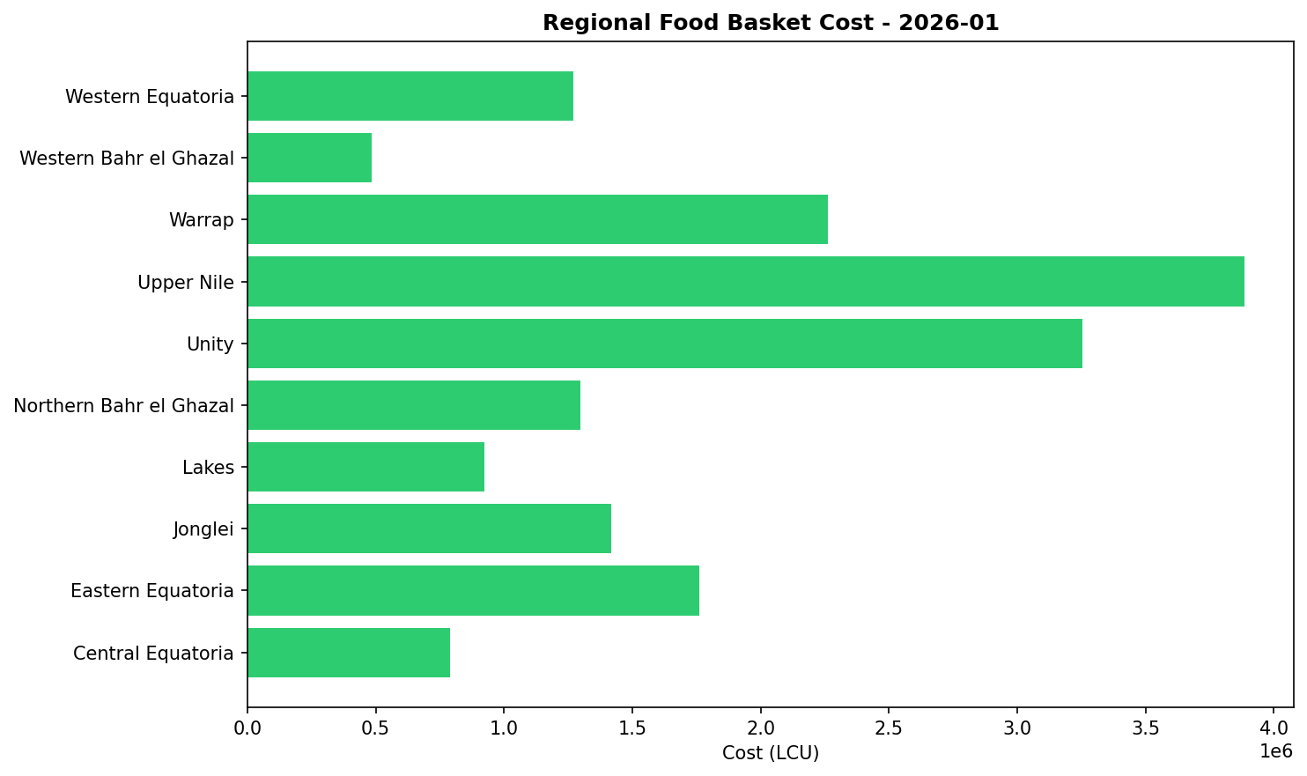

References
- [rw_4194069] ReliefWeb (2026-01-13) South Sudan: Humanitarian Needs and Response Plan 2026 (January 2026)
https://reliefweb.int/node/4194069
- [rw_4194038] ReliefWeb (2026-01-13) Humanitarian Feedback Bulletin: Accountability to Affected Populations - Renk, South Sudan I November 24 – December 6 2025 / Issue #12
https://reliefweb.int/node/4194038
- [rw_4193963] ReliefWeb (2026-01-12) Humanitarian Feedback Bulletin: Accountability to Affected Populations - Aweil, South Sudan I November 24 – December 6 2025 / Issue # 12
https://reliefweb.int/node/4193963
- [rw_4193930] ReliefWeb (2026-01-12) South Sudan : MVD Readiness (DREF Operation MDRSS018)
https://reliefweb.int/node/4193930
- [rw_4193581] ReliefWeb (2026-01-08) South Sudan: Food Security Outlook Update: Conflict disrupts humanitarian access, sustaining Emergency and risk of Famine in Nasir, December 2025
https://reliefweb.int/node/4193581
- [rw_4193350] ReliefWeb (2026-01-06) The South Sudan Roadmap on Anticipatory Action 2025 -2030
https://reliefweb.int/node/4193350
- [rw_4193308] ReliefWeb (2026-01-06) South Sudan Joint Market Monitoring Initiative (JMMI) 1 - 7 December 2025
https://reliefweb.int/node/4193308
- [rw_4193074] ReliefWeb (2025-12-31) South Sudan: MSF Evacuates Staff from Lankien Healthcare Facility Following Airstrikes
https://reliefweb.int/node/4193074
- [rw_4193033] ReliefWeb (2025-12-31) WFP South Sudan Country Brief, November 2025
https://reliefweb.int/node/4193033
- [rw_4192953] ReliefWeb (2025-12-30) South Sudan: Humanitarian Snapshot (November 2025)
https://reliefweb.int/node/4192953

